VM ASSIGNMENT
Q1 - Create 2 VMs (NAT + Host-Only) & Test Connectivity
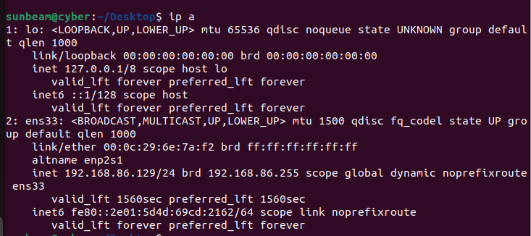
IP address of VM-1 (NAT)

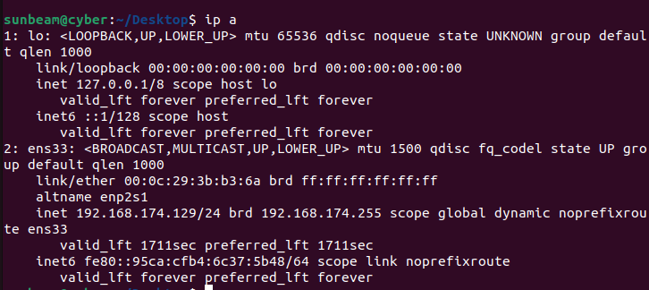
IP address of VM-2 (Host-Only)

Ping screenshots

Final answer: Explain whether NAT ↔ Host-Only communication works. Why/why not?
Communication between a NAT VM and a Host-Only VM does not work because both use completely separate virtual networks. NAT is used to give the VM internet access through the host, while Host-Only is an isolated private network used only for communication between the host and its VMs. Since these two networks are not connected and there is no routing between them, a VM on NAT cannot talk to a VM on Host-Only
Q2 - Create 2 VMs in NAT Mode & Test Connectivity
IP of VM1

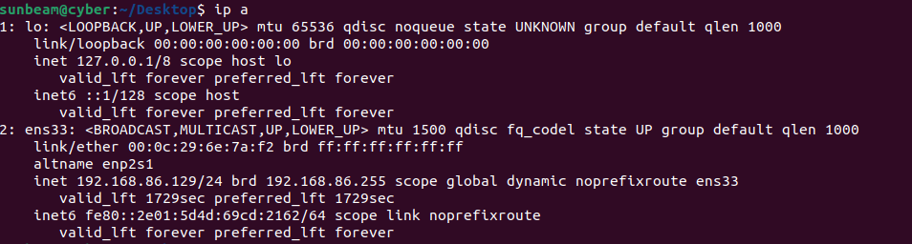
IP of VM2
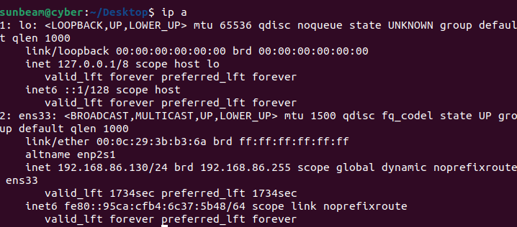

Ping results

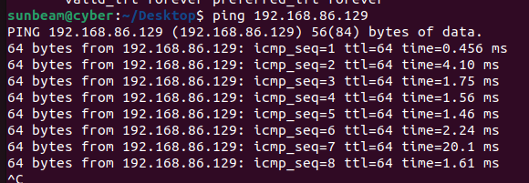
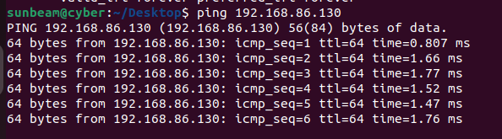

Do NAT VMs communicate inside the virtual network?
Yes, NAT VMs can communicate with each other inside the same virtual NAT network. When multiple VMs are connected to the NAT adapter, they are placed in the same internal virtual network created by the virtualization software. This allows them to send and receive data between each other just like computers on a small private LAN. However, they cannot be reached from outside this NAT network unless port forwarding is set up.

Q3 - Create 2 VMs in Host-Only Mode
IP of VM1
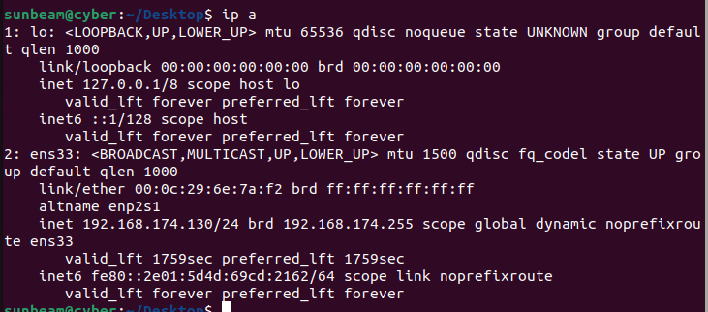
IP of VM2
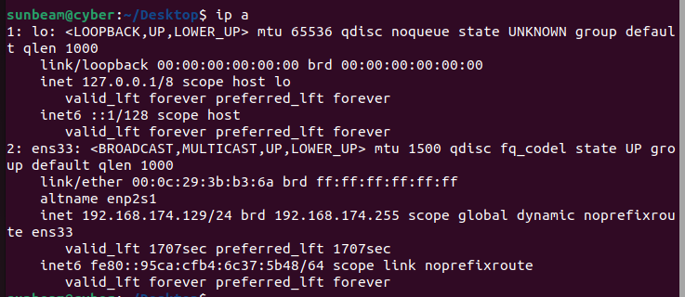

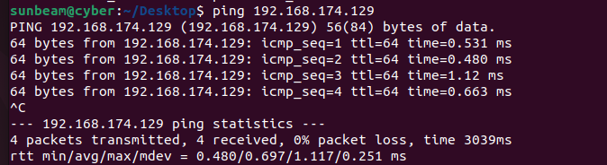
Ping VM-1 → VM-2
Ping VM-1 → Base Machine
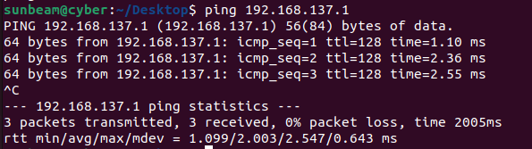
Ping VM-2 → VM-1
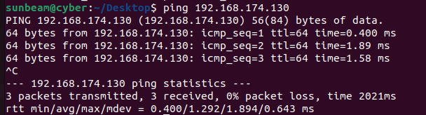
Ping VM-2 → Base Machine
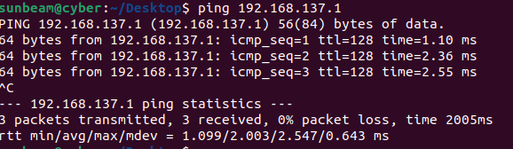
Q4 - Internet Connectivity Test (Different Modes)
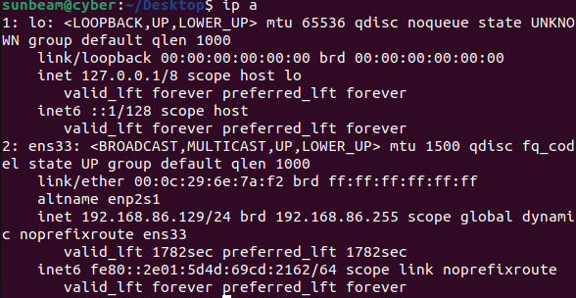
IP of NAT

Ping outputs
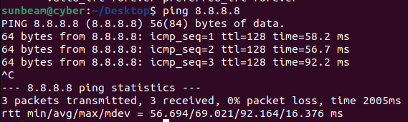

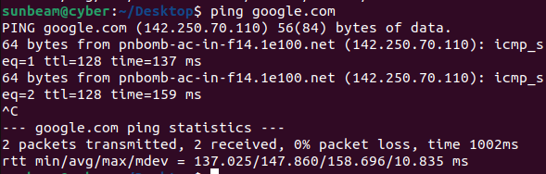

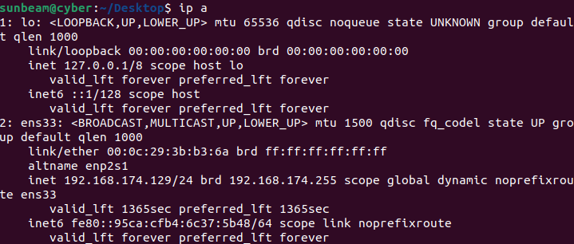
IP of Host-only

Ping outputs

Internet yes/no?

In NAT mode, the internet connection is available because the virtual machine uses the host system’s network to access the internet, so ping to external IPs and websites works.
In Host-Only mode, the internet connection is not available because the virtual machine can communicate only with the host system and not with external networks, so ping fails.

Q5 - Install Basic Utility Packages
1. Update package lists
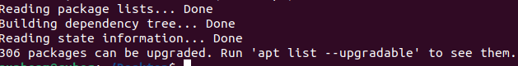
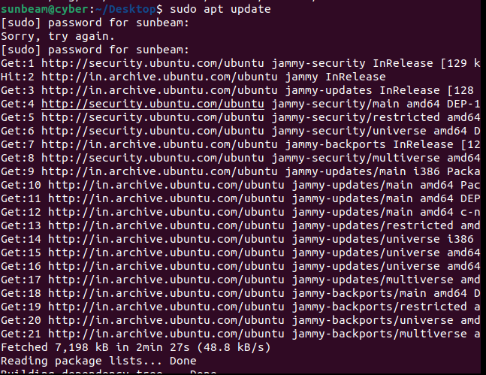

2. Install the following packages:
curl
tree
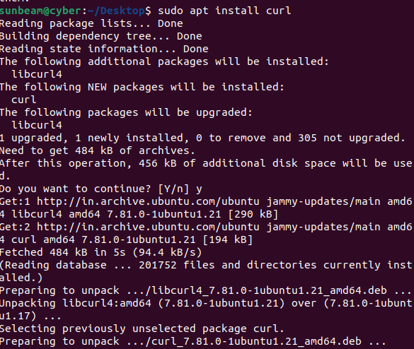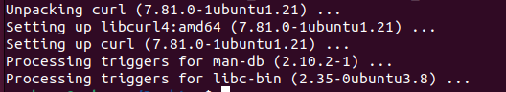
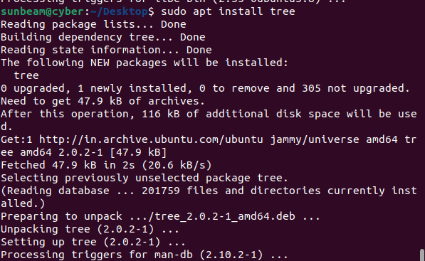
3. Verify installation:
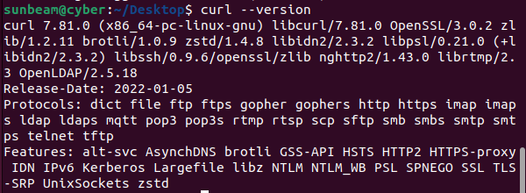

Q6 - Install a Package
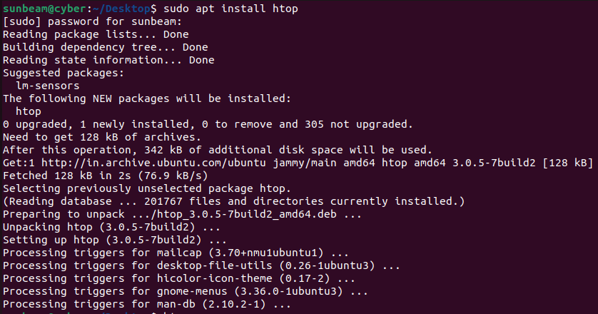
1. Install package htop .

2. Launch it:
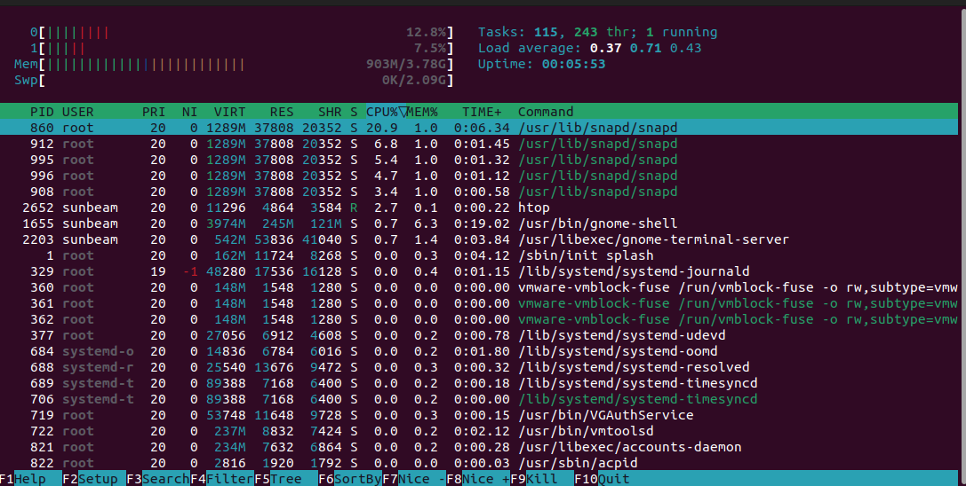

Q7 - Install Net-tools & Compare with ip Command

1. Install: sudo apt install net-tools

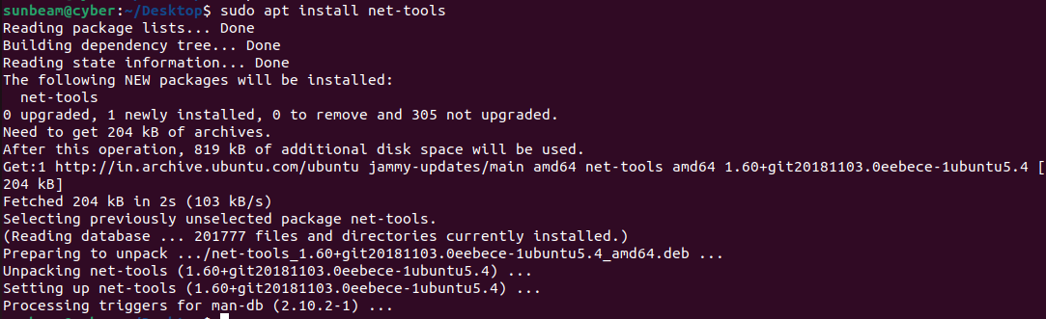
2. Run:
ifconfig
ip a
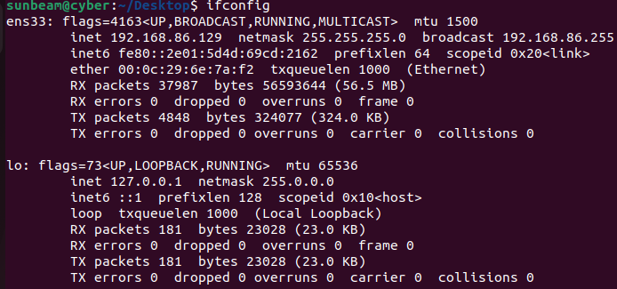

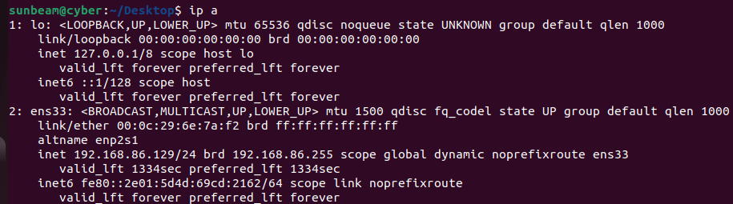
3. Compare both outputs Write differences.

ifconfig shows basic network details such as IP address, MAC address, and packets sent/received.
ip a shows more detailed and clear network information like interface state and IP lifetime.
ip a is the newer command and is preferred over ifconfig, which is an older command.

